**Team 4**

**Runhao Yang**

**Weigang Lin**

**Fang Ling**

**Zhongai Shi**

**May 11, 2019**

**Team 4 Systems Design Document**

**Table of contents**

**Page 1-2** System description

**Page 2-3** Timeline task list

**Page 3** Project timeline (Gantt Chart)

**Page 4** Context diagram

**Page 5** DFD-0

**Page 6** Use case with description

**Page 7-8** E-R Diagram

**Page 9-10** GUI Diagram

**Page 11-17** Data design and screenshots of testing cases

**System description**

The BMCC Hackathon software is a mobile/web based application specifically catering to BMCC students. The purpose of this system is to respond to the user's requirements while maximizing the value of resources in the hackathon, and reducing incidents and disruptions, and adding updates to the system. The system ensures that changes are recorded and evaluated and authorized changes are prioritized, planned, tested, documented and reviewed in a controlled manner. Additionally, the system ensures that changes to configuration items are recorded in the configuration management system and that it optimizes overall risk management.

The application handles numerous amounts of problems that typically occurs at a hackathon, such as overbooking a venue, missing badges, incomplete program information and insecure storage of staff passwords leading to transaction auditing difficulties. The application will have a registration and login page for BMCC students and staffs. Upon a successful login, users will be able to select their shirt size. A list of food vendors will be available, and ventor's contact information will be stored in a database. User's passwords will be encrypted with hashing in the database. A list of sponsors will be available as well as links to their websites. On the registration page, there will be a check mark option to select if the user is registering as a participant or a volunteer. Database will also contain prize, sponsors, vendors, admins, judges, and participants information. Sponsors will have their contact information, (name, phone, email, address, the amount of money that they had committed to the event, and the amount that has been paid). Vendors will have their own set of contact information as well, (name, phone, email). There will be two separate categories of vendors, a t-shirt vendor and a food vendor. Food vendors will have two category of food choices, vegetarian or meat. Participants, upon logging in, will be directed to a page where they will be able to see their contact information, their school name, and their team name. Additionally, they will be able to select their t-shirt size, their food choice, either vegetarian or meat.

**Projectile timeline (Gantt chart) + Timeline task list**

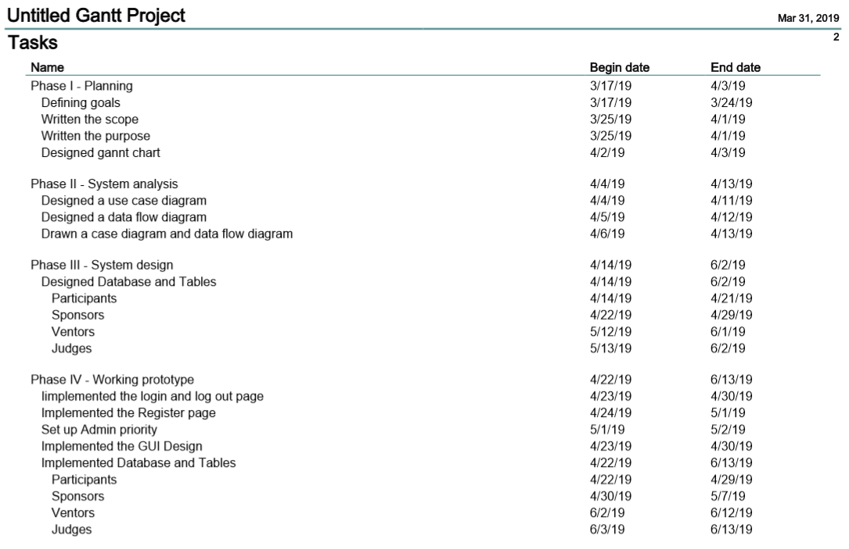

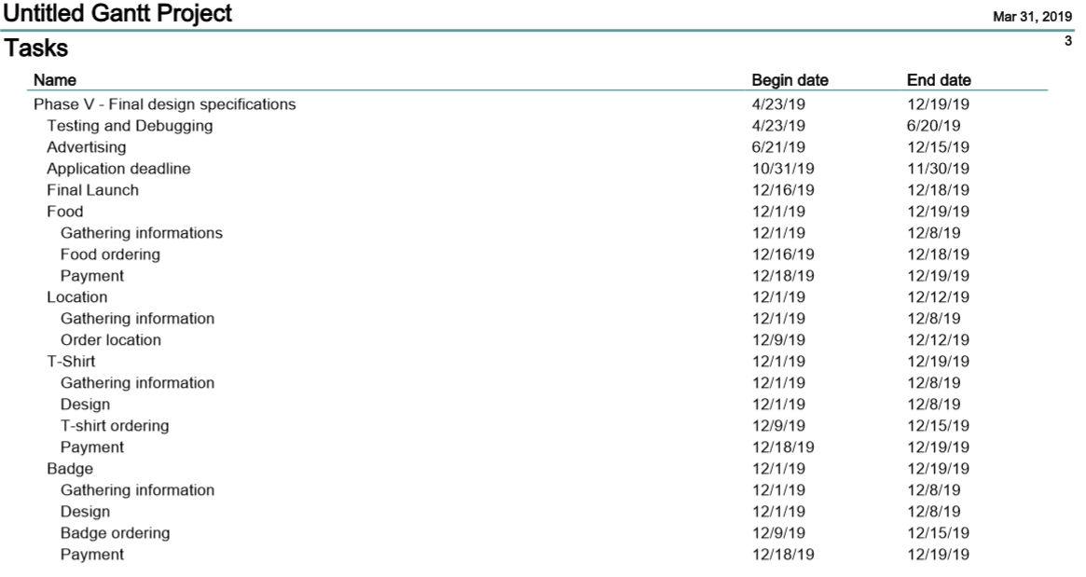

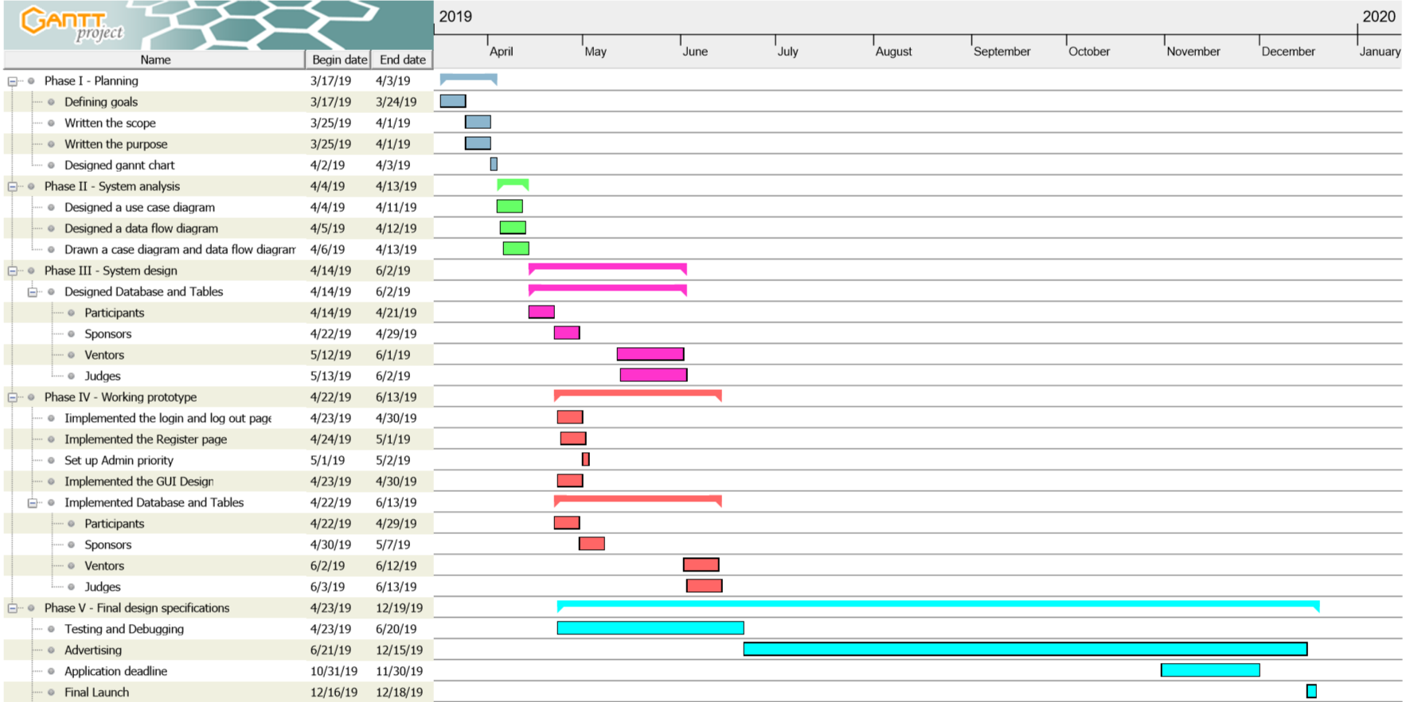

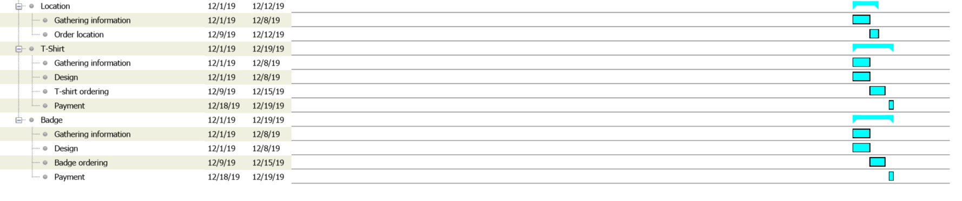

**Context Diagram**

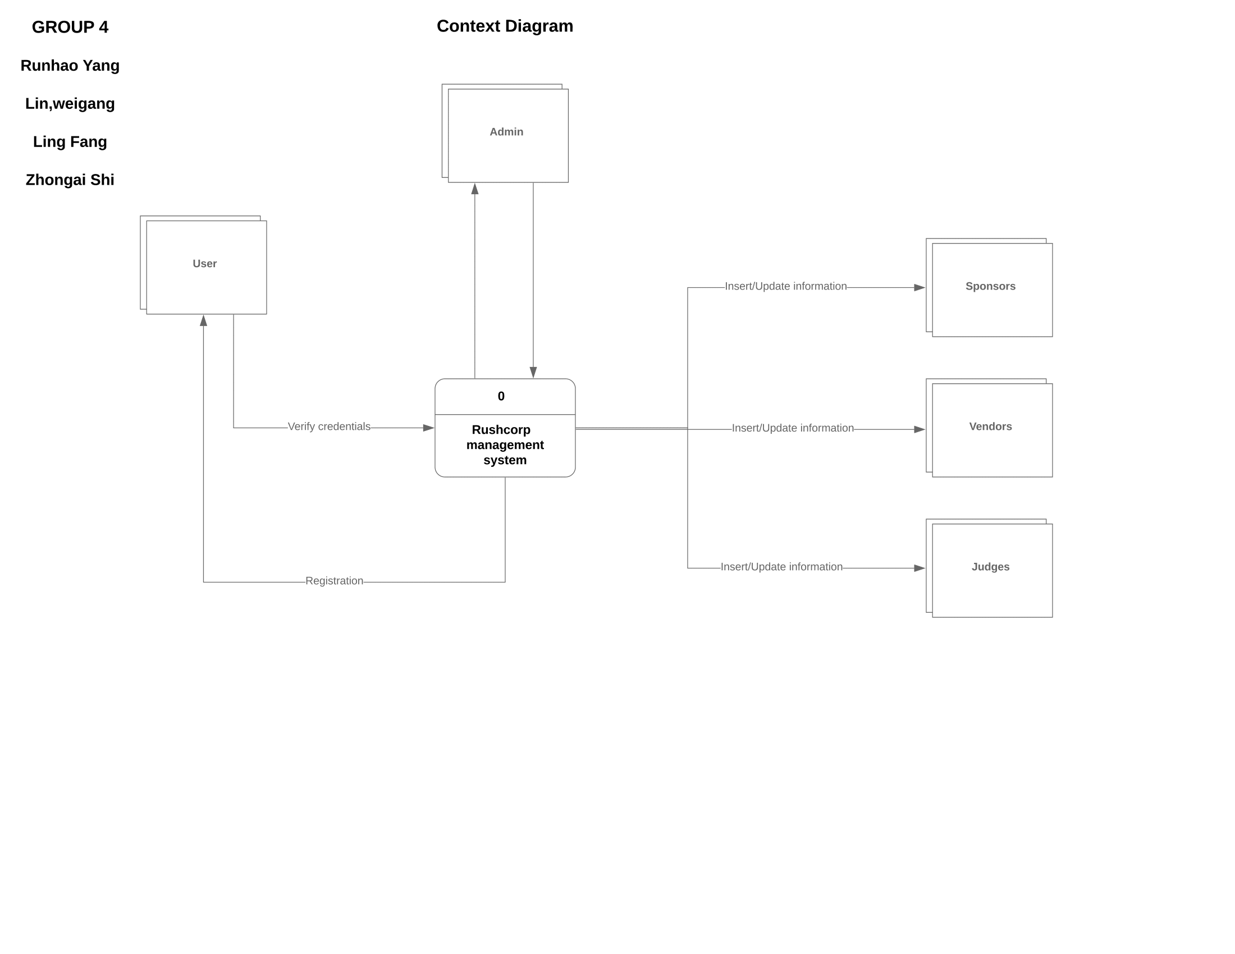

**DFD-0**

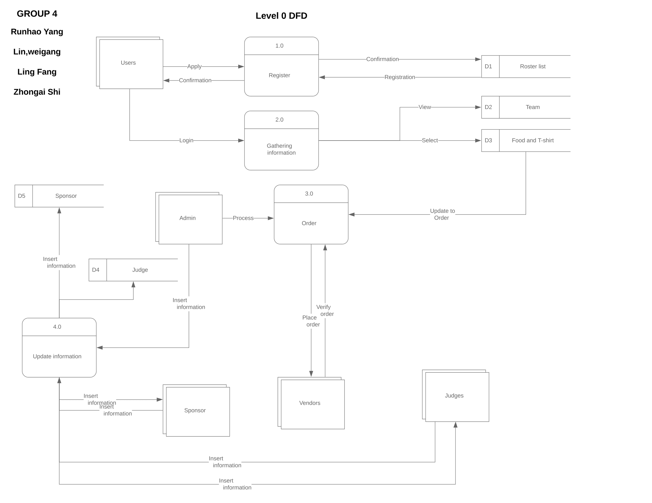

**Use-case diagram**

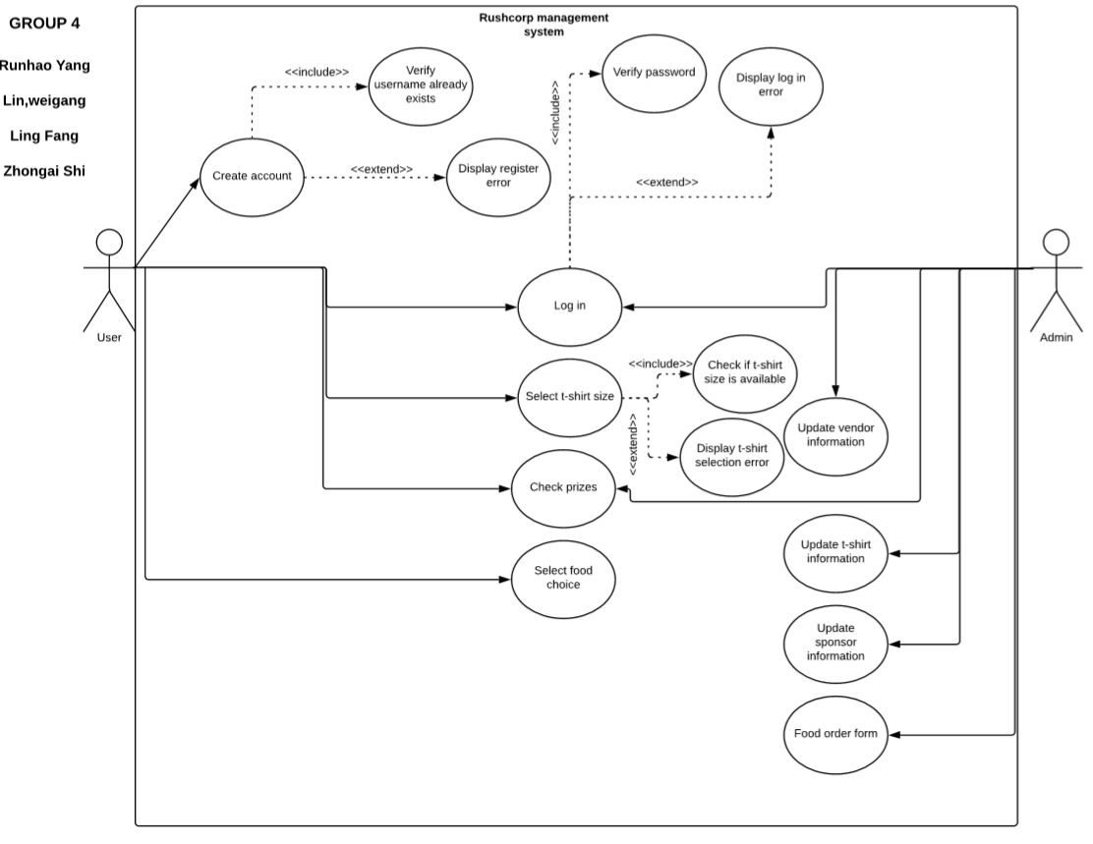

**E-R Diagram**

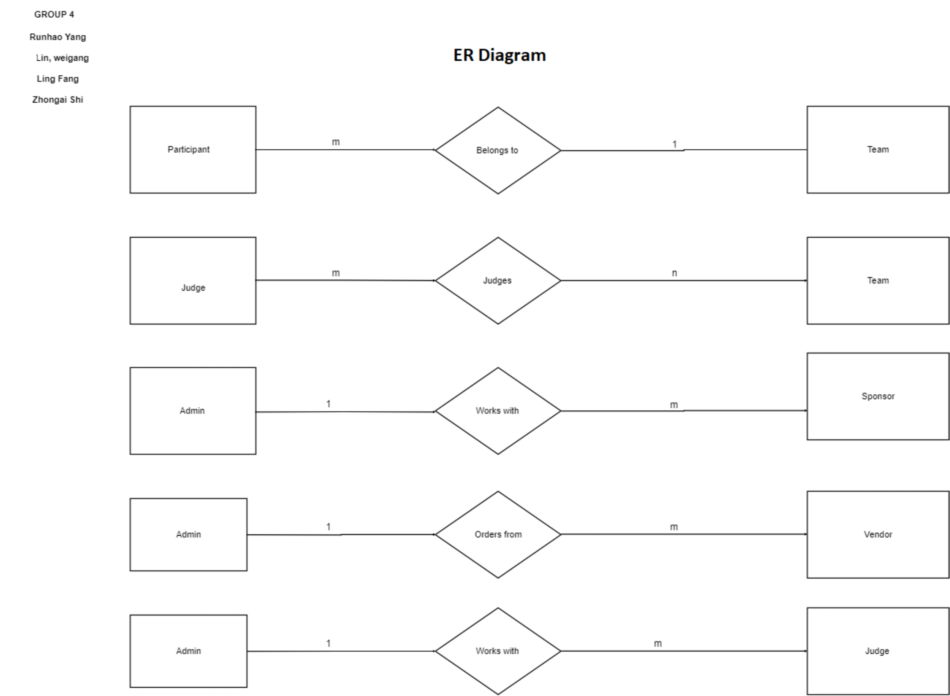

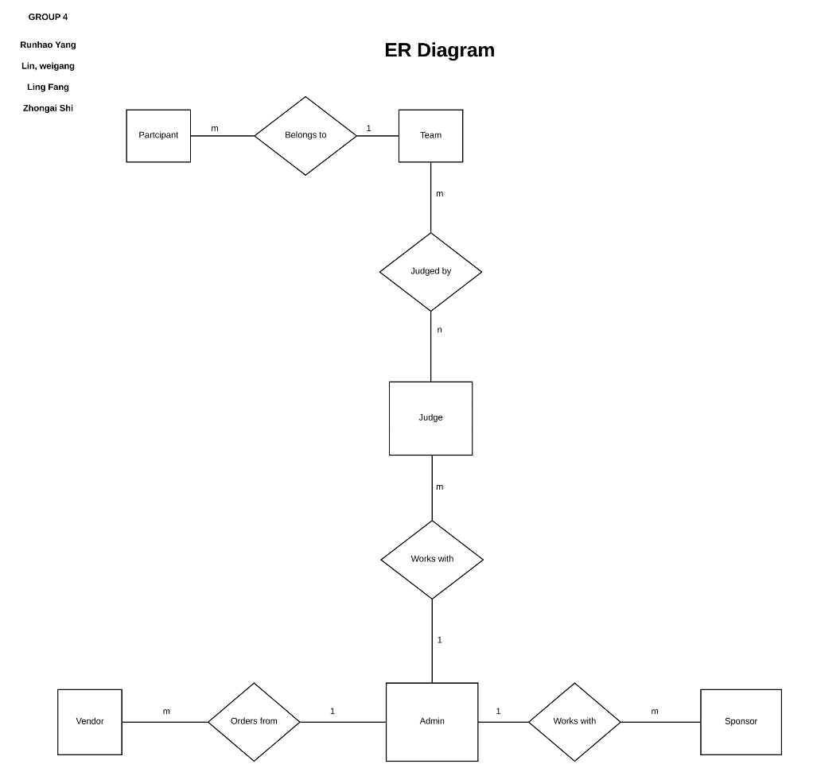

**GUI Diagram**

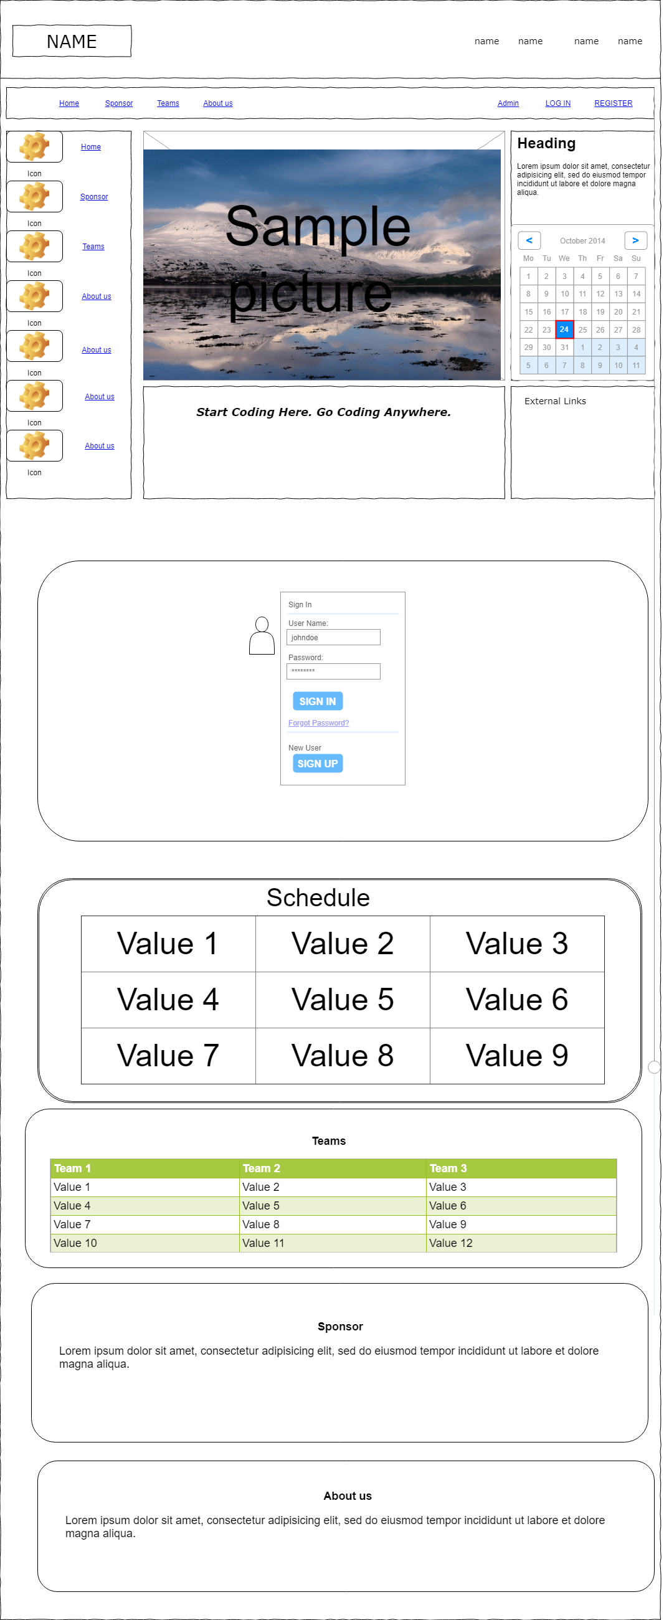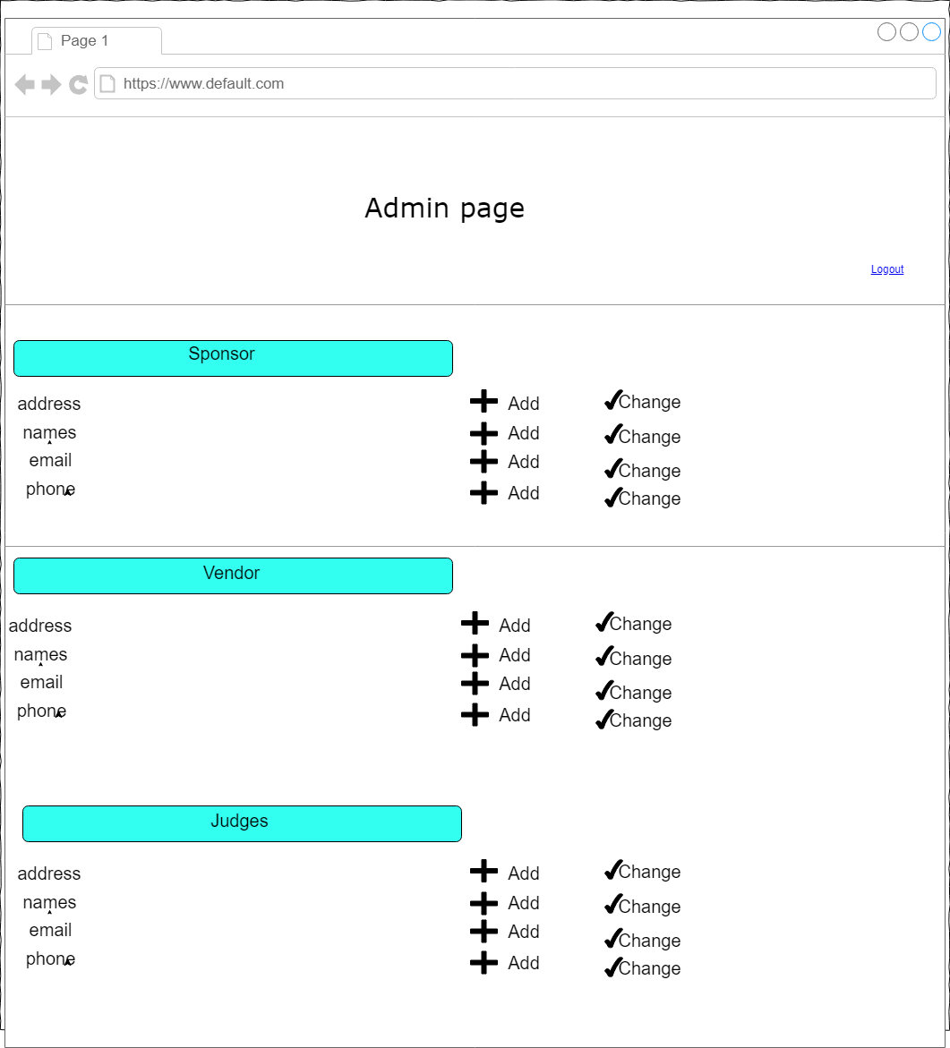

**Data design and screenshots of testing cases**

**Running this file will create a database called group4, and create 5 tables inside the group4 database. Additionally, the admin login information will be added to the admin table.** 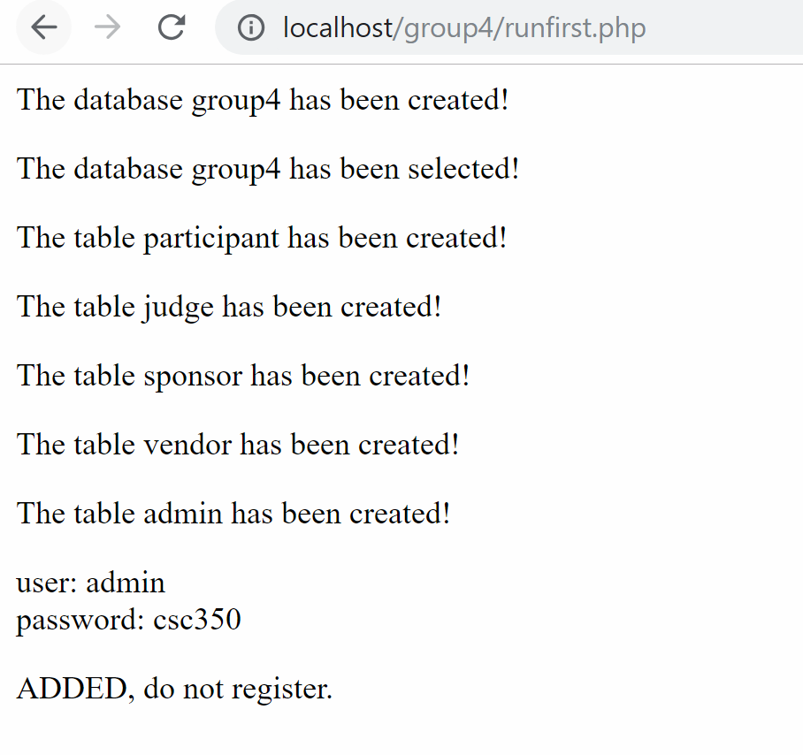

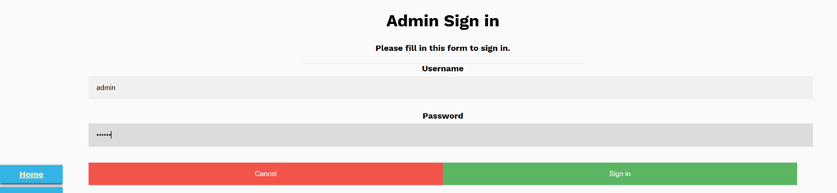

**Attempting to sign in with admin information**

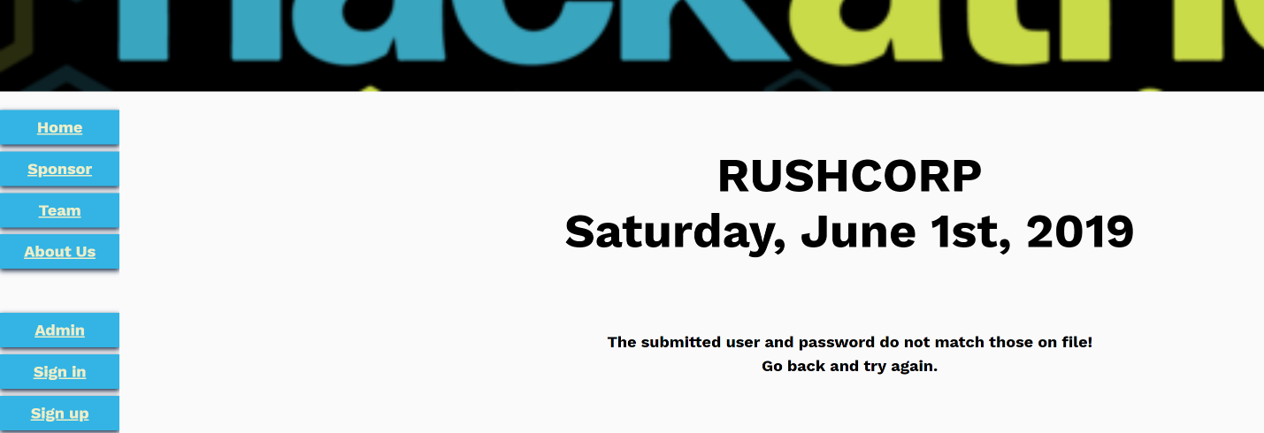

**Wrong admin password will display an error message and not redirect to the admin page**

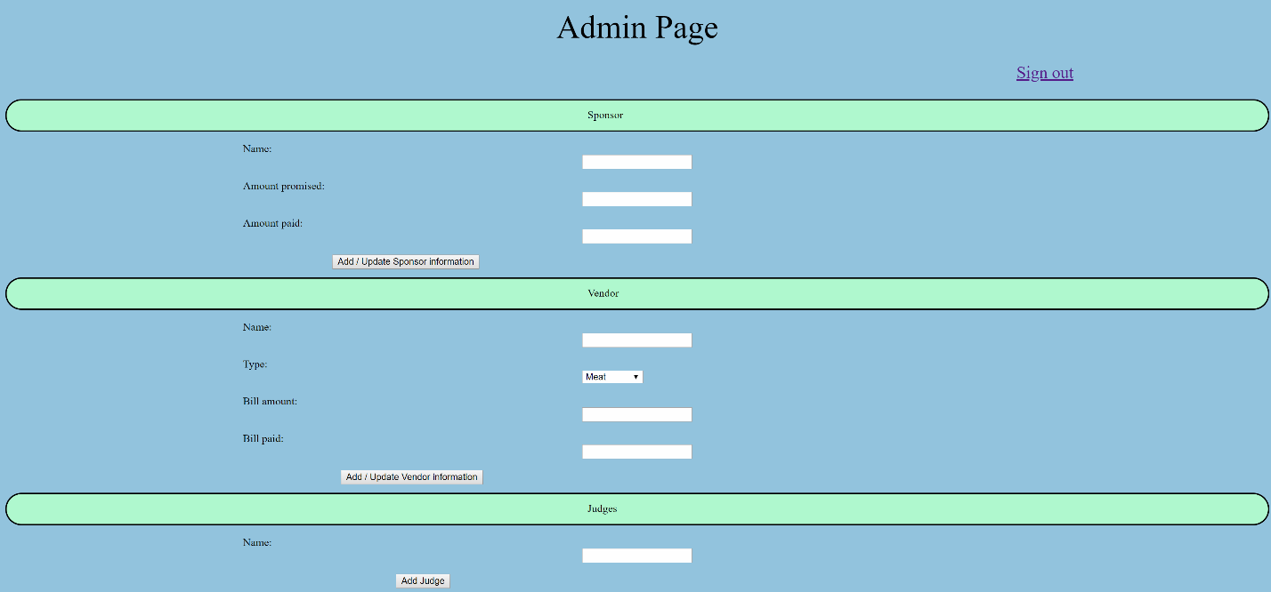

**Correct admin password will redirect to admin page**

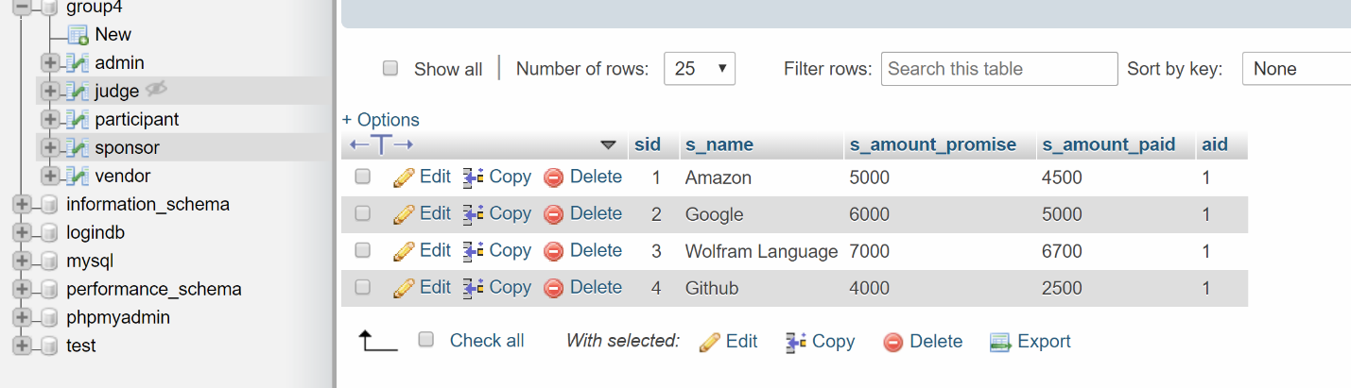

**Entering sponsor information and clicking on the Add / Update Sponsor Information sends the information to the sponsor table**

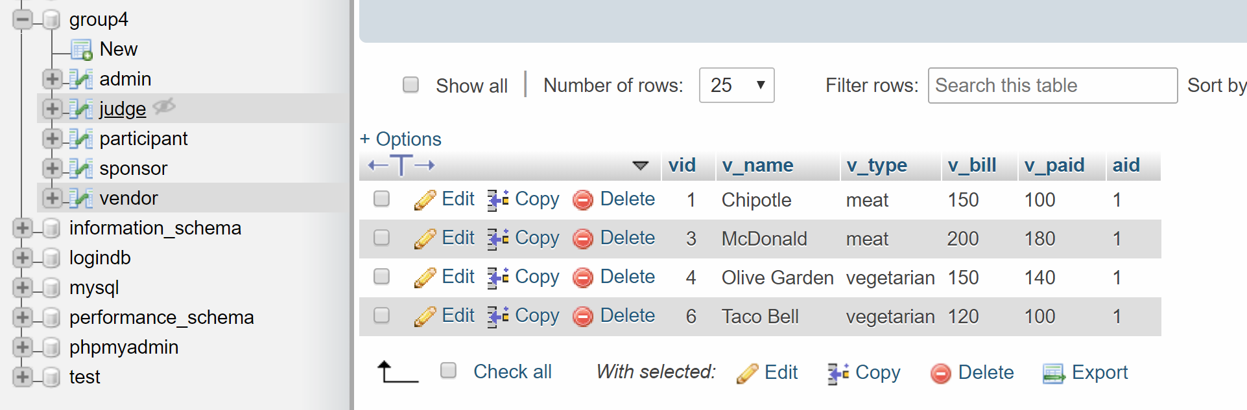

**Entering vendor information and clicking on the Add / Update Vendor Information sends the information to the sponsor table**

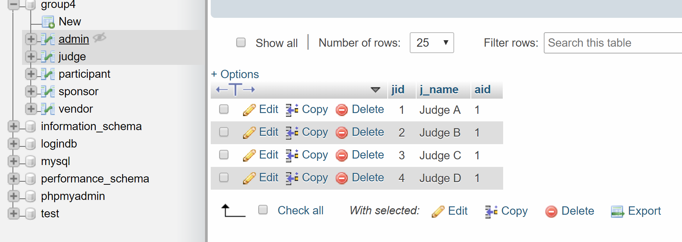

**Entering Judge information and clicking on the Add Judge sends the information to the judge table**

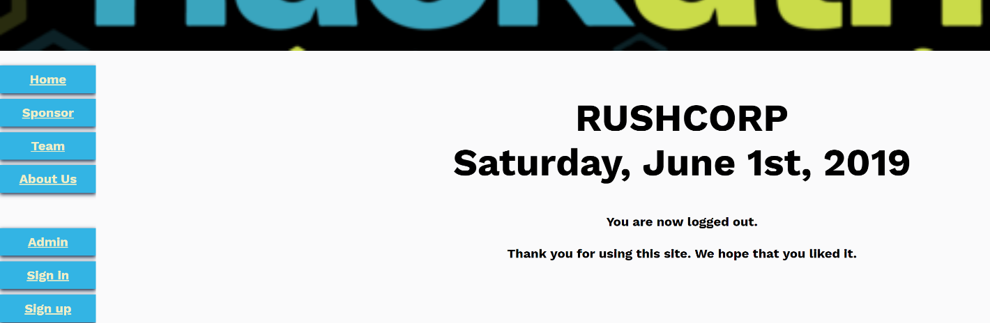

**Clicking on the Sign out button on the admin page will redirect to the sign out page, session id is destroyed**



**Attempting to click on the back button will not redirect to the admin page, as the session id is destroyed upon clicking on the sign out button, the user is directed back to the index.php page.**

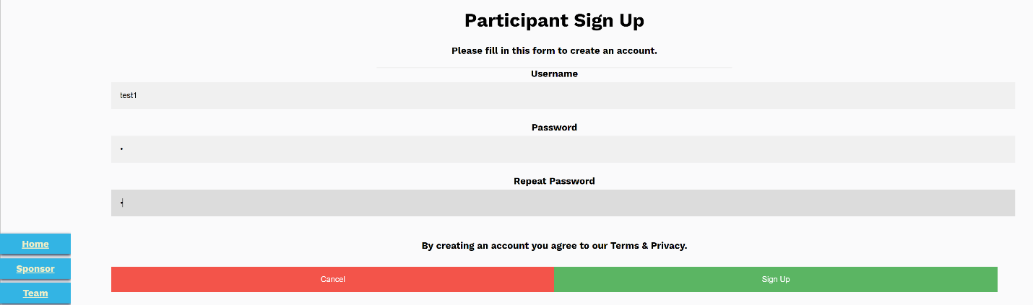

**Attempting to sign up**

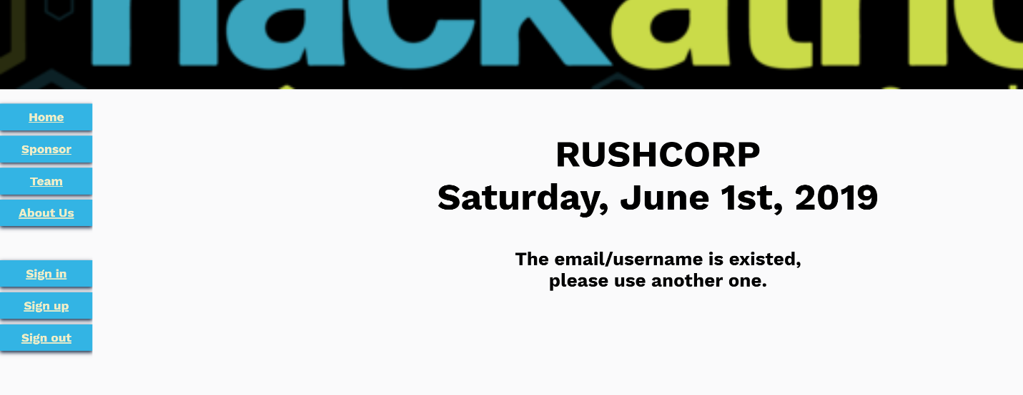

**An error message will display if the username already exists in the table participant.**

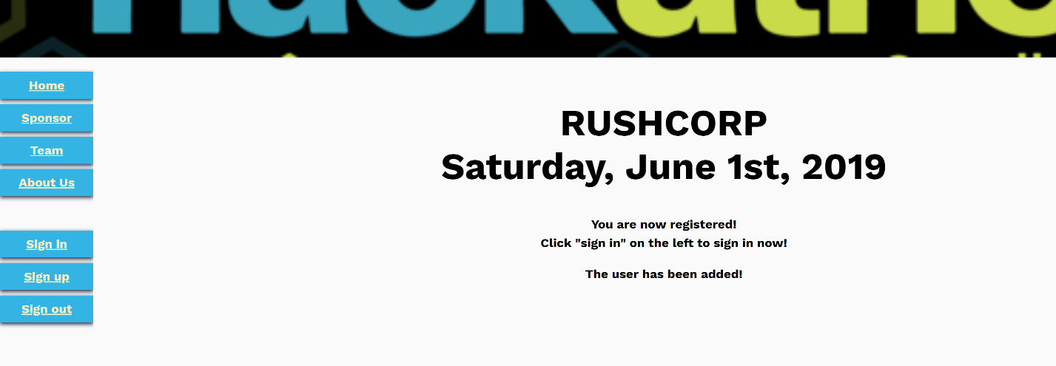

**If the username does not already exist in the table participant, then a sign up success page appears**

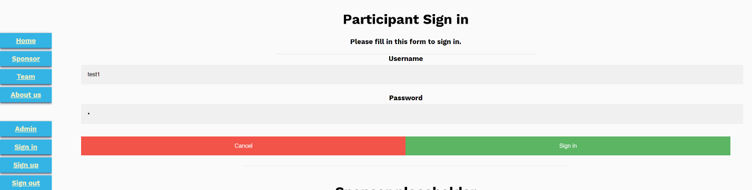

**Attempting to sign in**



**An error message will appear if the username or password is incorrect**

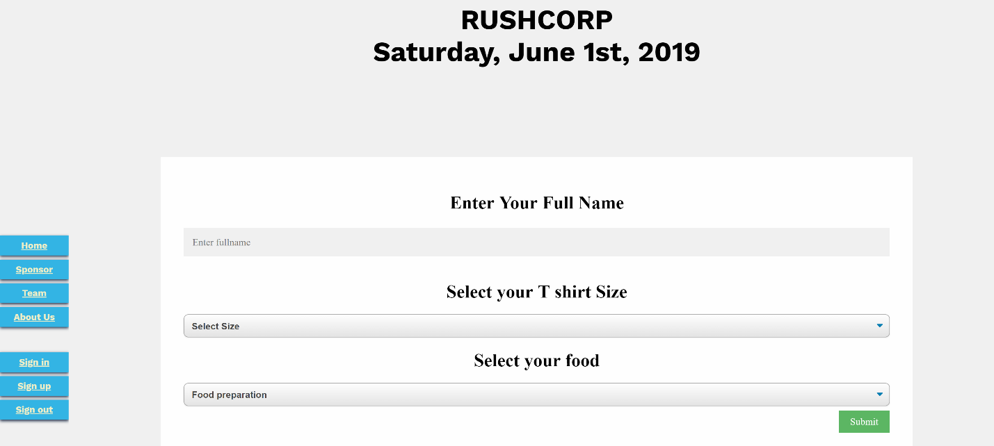

**A successful sign in will redirect the user to the participant page.**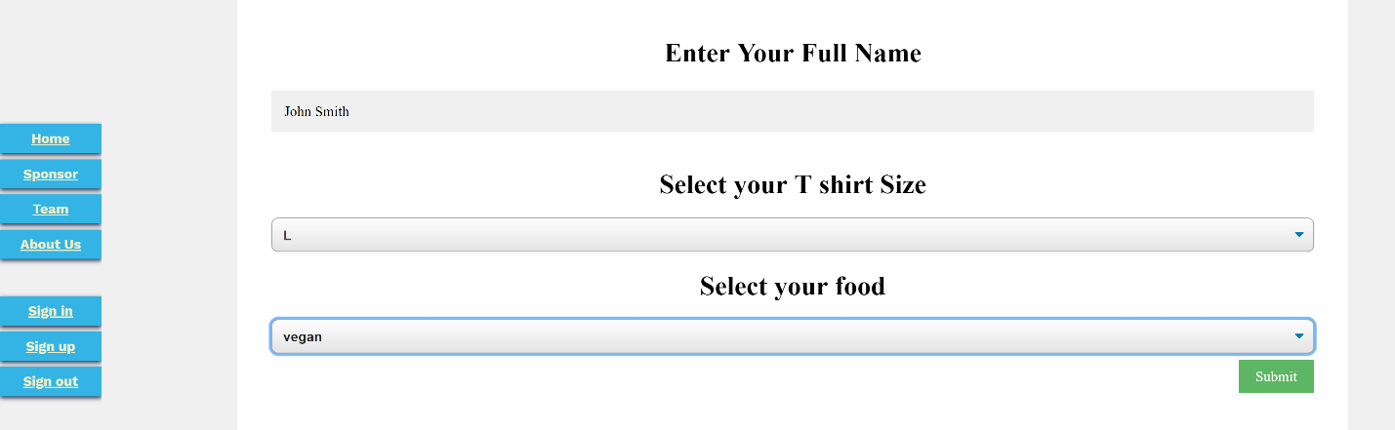

**Entering information and then clicking on the submit button**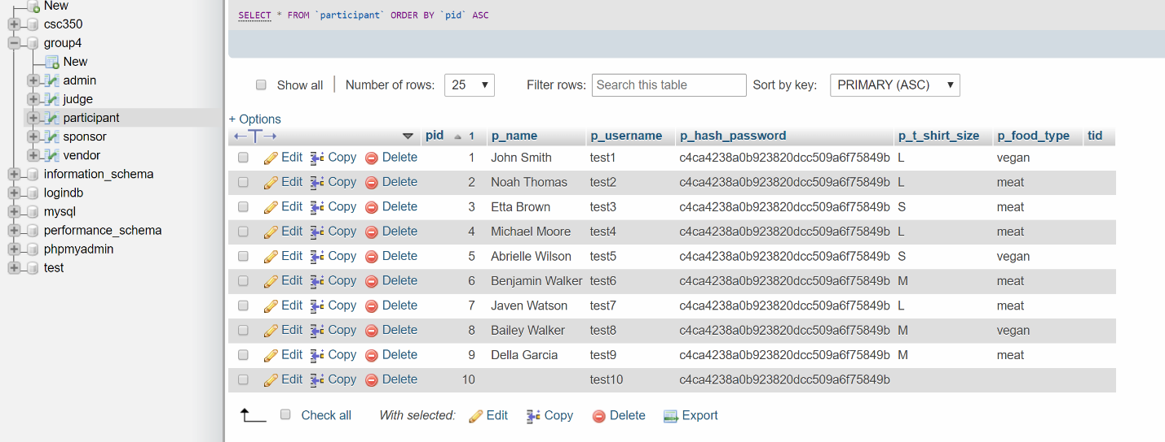

**p_name, p_t_shirt_size, and p_food_type are added/updated. Entering a new set of information will override the previous one, with the session id corresponding to the p_username of the user. **

**After clicking on the Sign out button**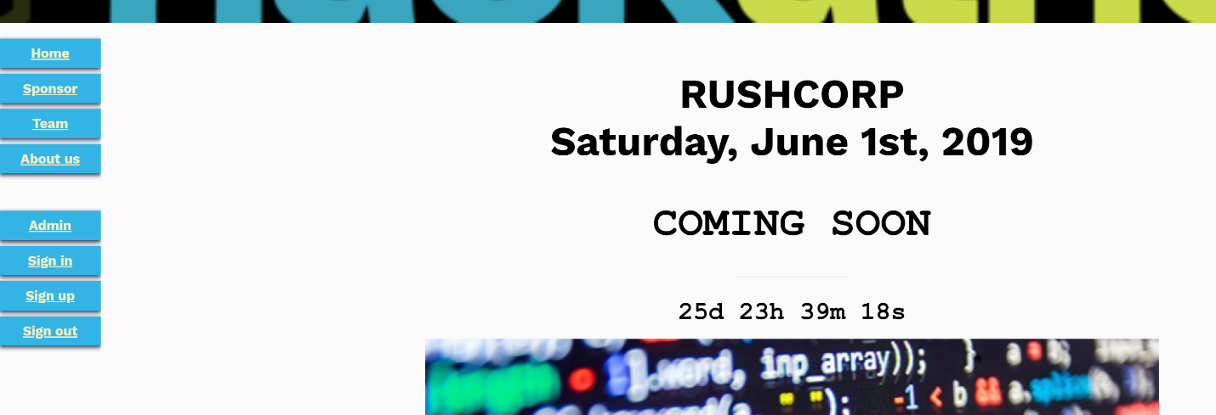

**Attempting to click on the back button will not redirect back to the participant page, as the session id is destroyed upon clicking on the sign out button, the user is directed back to the index.php page.**